Table of Contents
1. Login(TODO) 2
1.1 Login on 2
1.2 Login out 2
2. Document types 3
2.1 Creating document types 3
2.2 Viewing document types(TODO) 4
2.3 Document type examples 4
3. Document metadata 4
3.1 Creating metadata types 4
3.2 Assigning a metadata type to a document type 6
3.3 Metadata type examples 7
4. Document Upload 7
4.1 Step-by-step guide 7
Search Wizard 9
Users-Groups-Roles 9

1. Login(TODO)

1.1 Login on
? url

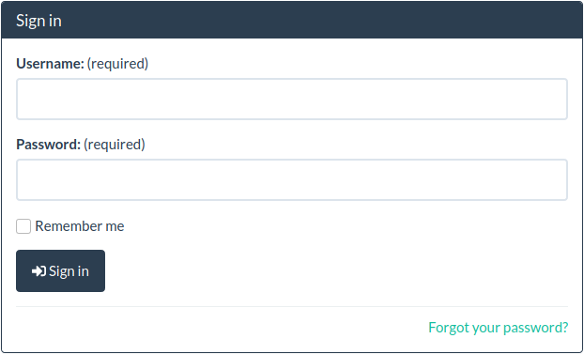
1.2 Login out
1. Go to User on the top right of home page.
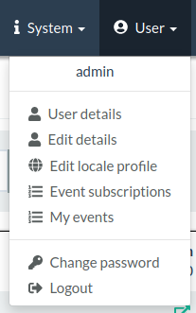
2. Click Logout.

2. Document types

- Document type are the most basic level of classification.
- Every document needs to be assigned to a document type.
- Documents can only be of one document type.
- The type of the document is chosen during upload but can also be changed afterwards.

2.1 Creating document types
► The “Create document types” permission is required for this action.
1. Go to the System→Setup→Document types.
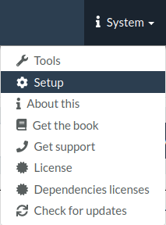
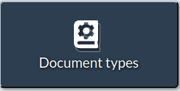
2. From the Actions dropdown select Create document type.
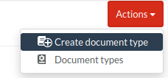
3. Enter a label.

2.2 Viewing document types(TODO)
Roles with permission “View document types” can view a list of types.
To restrict permission of viewing documents based on document types, see xxx(link to ACLs)

2.3 Document type examples
- Contract
- Insurance
- Invoice
- Meeting Minutes
- Receipt

3. Document metadata

- Metadata are custom properties. They extend the amount of information about a document.
- Metadata types are first created and associated to a document type before they can be used with documents.
- Metadata can be defined as optional or required.

3.1 Creating metadata types
►The “Create new metadata types” permission is required for this action.
1. Go to the System→Setup→Metadata types.
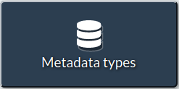
2. From the Actions dropdown select Create new.
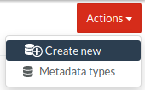
3. Fill in Name and give a short description as Label
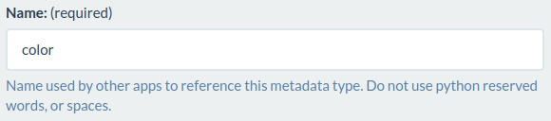
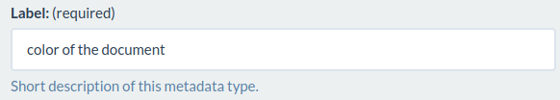
4. Optional:
Default: Enter a default value for the metadata type.
Lookup: Provide a comma separated list of options to restrict the data entry when using this metadata type.
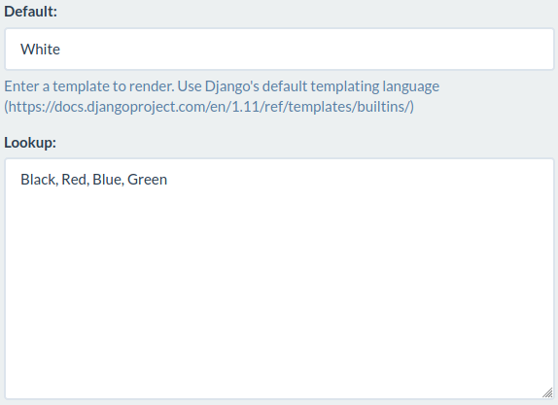
5. Save the metadata type.

3.2 Assigning a metadata type to a document type
1. Go to the System → Setup → Metadata types menu.
2. Click on the button Document types of the metadata type you wish to associate.
3. From the list of existing document types press either:

- None - if this metadata type will not be available for the type of documents.
- Optional - if this metadata type will be available and is optional to provide a value for the type of documents.
- Required - if this metadata type will be available and is required to provide a value for the type of documents.
4. Press Submit to save.

3.3 Metadata type examples
- Invoice number
- Colour
- Employee id
- Department

4. Document Upload
► The “Create documents” permission is required for this action.

4.1 Step-by-step guide
1. Locating Documents dropdown in the left navigation bar and click New document
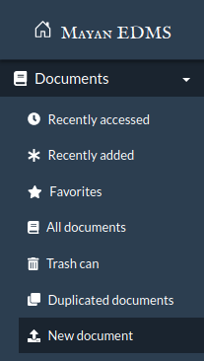
2. Following the document upload wizard
3. The first step is required. Select a document type for the document that will be uploaded.
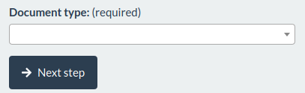
4. If there are metadata types associated with the selected document type, this next step will show a form allowing data entry for each metadata type for the new document. If there are required metadata types, a value must be entered before the wizard will allow progressing further. Click the Next step to continue.
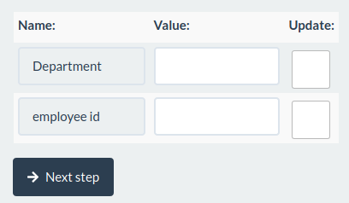
5. If tags have been created, this next step will show a form allowing the selection of multiple tags to attach to the new document. Click the button Next step to continue.
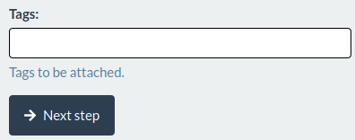
6. If cabinets have been created, this next step will show a form allowing the selection of multiple cabinets to which the new document will be added. Click the button Next step to continue.
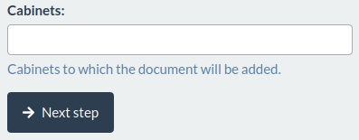
7. The upload form will be shown. Upload file by dragging and dropping or selected from file browser window.
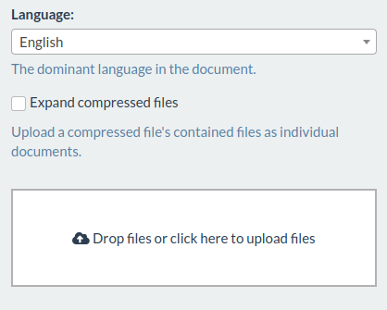
If there are pre-defined sources list on the right, choose a appropriate source when uploading.
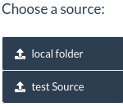

Search Wizard
Abcd

Users-Groups-Roles

